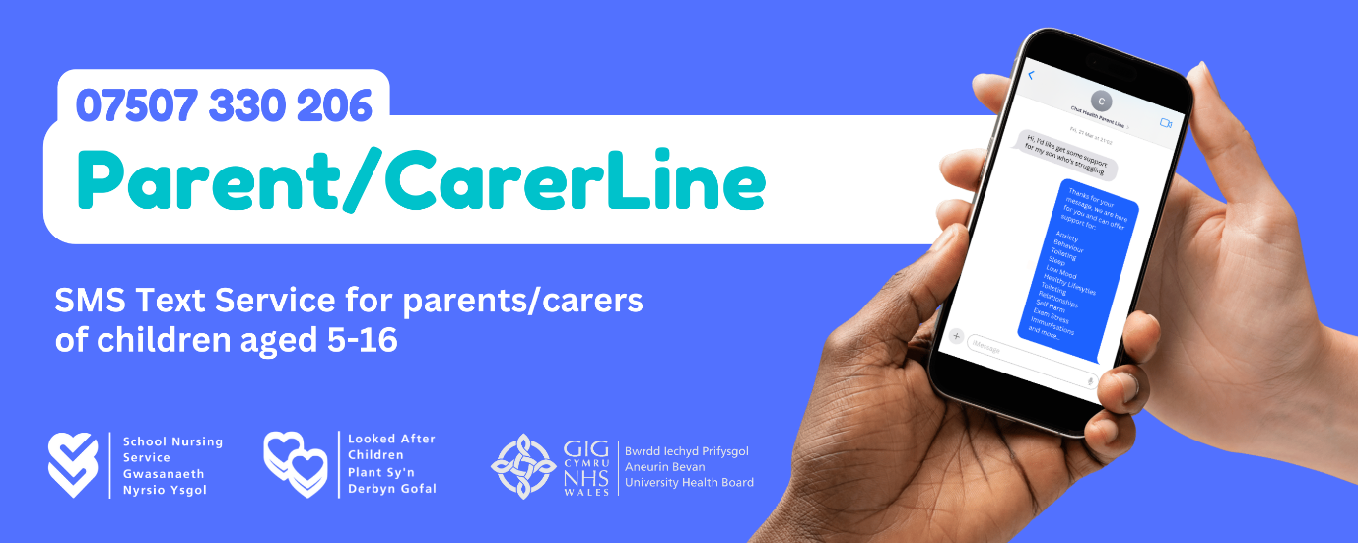
New NHS Text Service for Parents and Carers!
The School Nursing Service at Aneurin Bevan University Health Board are excited to launch Parent/CarerLine, a new SMS text service for parents and carers of children aged 5 to 16!
Parents and carers can text (SMS) our school nurses on 07507 330206 for expert advice and support with a child's health and wellbeing. Did you know, we also have a confidential text service for young people aged 11 – 19?
For more information on both services and to find out how our school nurses can support your child, visit: https://abuhb.nhs.wales/hospitals/childrens-healthcare-services/school-nursing/
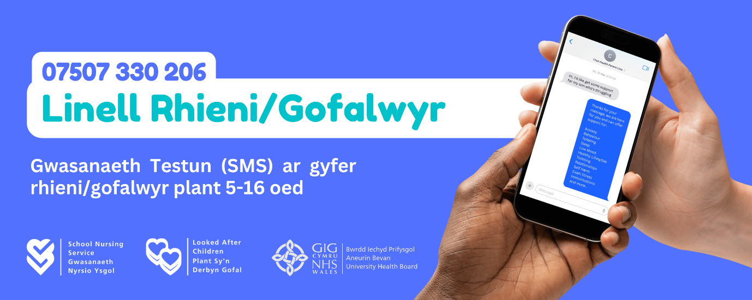
Gwasanaeth Neges Destun GIG Newydd i Rieni a Gofalwyr!
Mae Gwasanaeth Nyrsio Ysgol Bwrdd Iechyd Prifysgol Aneurin Bevan yn gyffrous i lansio Llinell Rhieni/Gofalwyr, gwasanaeth neges destun (SMS) newydd i rieni a gofalwyr plant 5 i 16 oed!
Gall rhieni a gofalwyr anfon neges destun (SMS) at ein nyrsys ysgol ar 07507 330206 i gael cyngor a chymorth arbenigol gydag iechyd a lles plentyn. Oeddech chi'n gwybod bod gennym ni hefyd wasanaeth neges destun cyfrinachol i bobl ifanc 11 – 19 oed?
Am ragor o wybodaeth am y ddau wasanaeth ac i ddarganfod sut y gall ein nyrsys ysgol gefnogi eich plentyn, ewch i: https://bipab.gig.cymru/ysbytai/gwasanaethau-gofal-iechyd-plant/nyrsio-ysgol/

